# https://upload.wikimedia.org/wikipedia/en/f/f1/Capital_University%2C_Jharkhand_logo.png

# CAPITAL UNIVERSITY - KODERMA

ELECTRIC MEASUREMENTS AND INSTRUMENTS ASSIGNMENT

Name : Arshad Nazir

Electrical and Electronics Engineering

Signature:

Date :

1. What is the use of swamping resistor?

Swamping resistor is a negative feedback resistor used in swamped amplifier to stabiles the voltage gain. To stabilize the voltage gain, emitter resistance is unbypassed, producing ac emitter feedback. The emitter current flows though the unbypassed emitter resistance and ac voltage appears across .

1. What is the electrical current effect used to produce deflecting torque in a PMMC instrument?

Electrostatic Effect :

The principle of operation of electrostatic instruments is the force of attraction or repulsion between two charged bodies, which leads to the production of deflecting torque.

1. Explain the terms resolution and sensitivity

RESOLUTION - the smallest portion of the signal that can be observed. SENSITIVITY - the smallest change in the signal that can be detected.

1. State two merits of PMMC ammeter Advantages
   * The PMMC consumes less power and has great accuracy.
   * It has a uniformly divided scale and can cover an arc of 270 degrees.
   * The PMMC has a high torque to weight ratio.
   * It can be modified as an ammeter or voltmeter with suitable resistance.
2. State two sources of error in moving iron instrument.

Errors in Moving Iron Instruments. There are two types of errors which occur in moving iron instruments: Errors with both AC and DC. Errors with AC only.

1. Define currentsensitivity of a galvanometer

The current sensitivity of the galvanometer is defined as the ratio of deflection produced in the galvanometer to the current flowing through it.

Mathematically, the current sensitivity of the galvanometer is given as Si = θ/I.

7.. List the various methods of providing control torque. What is controlling torque?

* + Spring Control Method. This is the most common method of providing controlling torque, in electrical instruments. ...
  + Gravity Control Method. ...
  + Air Friction Damping. ...
  + Fluid Friction Damping. ...
  + Eddy Current Damping.

1. What are the limitations of rectifier type instruments?

The rectifier type of instruments is not suitable even at high audio frequencies and for frequencies beyond audio frequency range. Because of the capacitance of the rectifier, inductance of the moving coil, the instrument fails at high frequencies indicating low value of reading.

1. What are the requirements of materials used in making shunts for extending range of instruments

So a good shunt should have the following properties:- 1- The temperature coefficient of shunt should be low 2- Resistance of shunt should not vary with time 3- They should carry current without excessive temperature rise 4- They should have thermal electromotive force with copper * 'Manganin' is used for DC shunt and …

1. List the various types of errors in electro dynamometer type instrument Errors in Electrodynamometer Type Wattmeter
   * Errors in the pressure coil inductance.
   * Errors may be due to pressure coil capacitance.
   * Errors may be due to mutual inductance effects.
   * Errors may be due connections. ...
   * Error due to Eddy currents.
   * Errors caused by vibration of moving system.
   * Temperature error.
2. How is the current range of PMMC instrument extended with the help of shunts?

When using a PMMC meter as an ammeter, its range of measurement can be extended further with the help of parallel connected “Shunt Resistors”, thus allowing it to measure DC currents many times greater than its normal full-scale deflection current rating as only a fraction of the total current will pass through the …

1. List out commonly used damping methods?

There are four different ways of producing damping torque, these include air friction damping, fluid friction damping, eddy current damping, and electromagnetic damping.

1. What is the use of thermal instruments?

Since 1959, Thermal Instrument has produced mass flow meters that help increase productivity with accurate and dependable measurements of liquids and gases for both industrial and environmental processes.

1. How to extend the range of voltmeters?

To increase the ranges of a voltmeter, we need to connect a high series of multiplier resistance in series with voltmeters. We can extend the range of ammeter by keeping a shunt resistance. As the two resistances, Rm and Rsh are in parallel, the voltage drop across the resistance is equal.

1. What is shunt? Explain briefly?

In electronics, a shunt is a device that creates a low-resistance path for electric current, to allow it to pass around another point in the circuit. The

origin of the term is in the verb 'to shunt' meaning to turn away or follow a different path.

1. Why electrodynamometer type instrument is called transfer instruments?

These instruments have the same accuracy for both dc and ac. Explanation: Precision type electrodynamometer (EMMC) is used in the

standardization process of the potentiometer and hence It is a transfer instrument.

1. An ohmmeter is MI or MC or dynamometer type?

An ohmmeter is an electrical instrument that measures electrical resistance (the opposition offered by a circuit or component to the flow of electric current).

1. Give the expression for torque in moving coil instruments

The value of control torque depends on the mechanical design of spiral springs and strip suspensions. The controlling torque is directly proportional to the angle of deflection of the coil. Control torque Ct =Cθ where, θ = deflection angle in radians and C = spring constant Nm /rad .

1. What is the use of a rectifier instruments?

Rectifier type instruments are used for measurement of AC voltages and currents by employing a rectifier element. This rectifier converts AC to a unidirectional DC and then using a meter responsive to DC to indicate the value of rectified AC. The indicating instrument is PMMC instrument which has a linear scale.

1. Explain in detail about Ballistic galvanometer.

A ballistic galvanometer is a type of sensitive galvanometer; commonly a mirror galvanometer. Unlike a current-measuring galvanometer, the moving part has a large moment of inertia, thus giving it a long oscillation period. It is really an integrator measuring the quantity of charge discharged through it.

1. (i) Describe the working principle of thermal type meter. (ii) Problem on PMMC instrument

The thermal mass meter measures gas flow based on the concept of convective heat transfer. Gas flows by the heated flow sensor, and molecules of the gas transport heat away, the sensor cools, and energy is lost. ... In either case, the meter's probe inserts into a gas stream of a pipe, stack, or duct.

The basic sources of error in PMMC instruments are friction, temperature and aging of various parts. To reduce the frictional errors ratio of torque to weight is made very high. The most serious errors are produced by the heat generated or by changes in the temperature.

1. What are the causes of creeping in an energy meter?

The main reason for creeping is overcompensation for friction i.e., low load adjustment of energy meter. Under the light load condition, due to friction adjustment using shading loop. The shading loop produces a starting torque on the disc which is irrespective of the load current, thus increases the meter reading.

1. How is creep effect energy meters avoided?

The creeping is avoided by drilling the hole in the disc. The holes are diametrically opposite to each other. The aluminium disc stops rotating even when the small edge of the disc come under the pole of the magnet. The holes will limit the revolution of the disc.

1. List the different types of wattmeter

There are two types of Wattmeter given below:

* + Dynamometer Type Wattmeter.
  + Induction type Wattmeter.

1. How is LPF wattmeter different from UPF wattmeter?

LPF wattmeter is used to measure power in inductive circuits. Inductive circuits have the property of lagging power factor and hence these wattmeters are used. ... So UPF(Unit Power Factor) Wattmeter is used in SHORT CIRCUIT TEST of Transformer.

1. What is phantom loading?

Phantom Loading is a loading condition in which an energy meter is connected to factious or phantom load for testing of energy meter with high current rating. Such loading is favorable to avoid wastage of energy during the test of measurement instrument.

1. List the errorsin electro dynamometer type wattmeter Errors in Electrodynamometer Type Wattmeter

Errors in the pressure coil inductance. Errors may be due to pressure coil capacitance. Errors may be due to mutual inductance effects. Errors may be due connections.

1. What are two classes of dynamometer wattcmeters? Dynamo meter type watt meter
   * This type of watt meter consists of two types of coil, more specifically current coil and voltage coil. ...
   * As simple as other voltmeter and ammeter connection. ...
   * When current flows through the current coils, then automatically a magnetic field is developed around those coils.
2. What is the expression for reactive power in 3-phase circuits?

Actually in three phase system, the reactive power in each individual phase is not zero but sum of them at any instant is zero. Reactive power is the form of magnetic energy, flowing per unit time in an electric circuit. Its unit is VAR (Volt Ampere Reactive). This power can never be used in an AC circuit.

1. Which of the coils of a wattmeter has a high resistance and which is thicker?

Which of the coils of a wattmeter has a high resistance and which is thicker? Pressure coil of wattmeter has high non-inductive resistance to limit the current to small value which proportional to the voltage applied. Current coil of wattmeter is thicker to carry considerable current.

1. How to prevent creeping in energy meters?

To prevent creeping, two diametrically opposite holes are drilled in the disc of energy meters. Due to this hole, the disc will come to rest when the hole comes under the edge of the pole of the shunt magnet. Thus creeping is limited to a maximum of half of the rotation.

1. What are motor meters?

A motor meter is a device used to monitor an engine's running time In

many cases, a motor meter will be compared to a vehicle's odometer. The typical use for a motor meter is to monitor diesel engine run time.

1. Define burden of an instrument transformer.

Burden is the small voltage drop across the reflected impedance of the secondary in the primary. Since the primary is normally one turn and the turns ratio is high and the secondary effectively shorted by a current instrument.

1. What are the advantages of instrument transformers over shunts and multipliers?

They have the following advantages. The power loss in a transformer is small, whereas the power loss in a resistance shunt or multiplier may be considerable. The instrument operated may be well removed from all high- voltage conductors.

1. State two applications of CT and of PT

CT and PT are used where large quantities of currents and voltages are used. The job of CT and PT is to reduce high current and high voltage to a parameter. With the help of this parameter, we can measure the current flowing at high volume and voltage.

1. State and explain the basic principle of potentiometer

The principle of a potentiometer is that the potential dropped across a segment of a wire of uniform cross-section carrying a constant current is directly proportional to its length. ... Between the end of the wire and any point along it will be a potential proportional to the length of wire to that point.

1. Define nominal and turnsratio of an instrument transformer

The nominal ratio is defined as the ratio of rated primary quantity to the rated secondary quantity, cither current or voltage. 3. Turns ratio [n] Ratio Correction Factor (RCF) It is the ratio of transformation i.e. actual ratio to the nominal ratio.

1. How are AC potentiometers classified? List them.

Whereas an AC potentiometer measures both the magnitude and phase of unknown voltage by comparing it with a known reference. There are two

types of AC potentiometers: Polar type potentiometer. Coordinate type potentiometer.

1. What is the use of a potentiometer?

A potentiometer is a type of position sensor. They are used to measure displacement in any direction. Linear potentiometers linearly measure displacement and rotary potentiometers measure rotational displacement.

1. What is the advantage of venire potentiometer over slide type?

Potentiometer works on zero deflection method so possibility of error is very small. The standardization of potentiometer can be done directly with a standard cell. This is highly sensitive so can be used to measure small emf's.

1. What is the need for phase shifters in a polar type A.C potentiometers.

To produce the rotating magnetic field which passes through the air gap between its stator and rotor and induces an emf in the rotor winding. To provide the required phase shifting of the rotor induced emf by adjusting the rotor position.

1. Describe the working and construction of a co-ordinate type ac potentiometer.

A [potentiometer](https://www.electrical4u.com/potentiometer-working-principle-of-potentiometer/) is an instrument which measures unknown voltage by balancing it with a known [voltage](https://www.electrical4u.com/voltage-or-electric-potential-difference/). The known source may be DC or AC. The working phenomenon of DC potentiometer and AC potentiometer is same. But there is one major difference between their measurements, DC potentiometer only measures the magnitude of the unknown voltage.

Whereas an AC potentiometer measures both the magnitude and phase of unknown voltage by comparing it with a known reference. There are two types of AC potentiometers:

* 1. Polar type potentiometer.
  2. Coordinate type potentiometer.

Polar type Potentiometer

In such type of instruments, two separate scales are used to measure magnitude and phase angle on some reference of the unknown e.m.f. There is a provision on the scale that it could read phase angle up to 3600.

It has [electrodynamometer](https://www.electrical4u.com/electrodynamometer-type-wattmeter/) type [ammeter](https://www.electrical4u.com/ammeter/) along with DC potentiometer and phase-shifting [transformer](https://www.electrical4u.com/what-is-transformer-definition-working-principle-of-transformer/) which is operated by single phase supply.

In a phase-shifting transformer, there is a combination of two ring-shaped laminated steel stators connected perpendicularly to each other as shown in the figure. One is directly connected to power supply and the other one is connected in series with variable resistance and capacitor. The function of the series components is to maintain constant AC supply in the potentiometer by doing small adjustments in it.

Between the stators, there is laminated rotor having slots and winding which supplies voltage to the slide-wire circuit of the potentiometer. When [current](https://www.electrical4u.com/electric-current-and-theory-of-electricity/) start flowing from stators, the rotating field is developed around the rotor which induces an e.m.f. in the rotor winding.

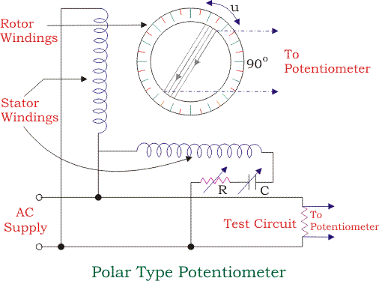

The phase displacement of the rotor emf is equal to rotor movement angle from its original position and it is related to the stator supply voltage. The whole arrangement



Now to measure unknown e.m.f. its terminals are connected across sliding contacts AA’ using selector switch S3. By doing some adjustments in sliding contacts and rheostat, the whole circuit gets balanced and galvanometer reads zero at the balanced condition. Now the in-phase component VA of the unknown e.m.f. is obtained from the in-phase potentiometer and quadrature component VB is obtained from quadrature potentiometer.

Thus, the resultant voltage of the coordinate AC potentiometer is



And the phase angle is given by



Applications of AC Potentiometer

* 1. Measurement of self-inductance.
  2. Calibration of voltmeter.
  3. Calibration of Ammeter.
  4. Calibration of watt meter.

1. 2. (i) Draw the equivalent circuit and phasor diagram of a CT. (ii)Derive the expression for ratio and phase angle error.

Current Transformer is an instrument transformer which steps down high value of current to a low value of current suitable for measurement devices. It is widely used in power system for measurement and protection purpose. We cannot think of power generation, transmission or distribution without using Current Transformer.

Construction of Current Transformer (CT):

There are two windings in a Current Transformer which are wound around a magnetic core. The winding having fewer numbers of turns is called Primary Winding and the winding having more turns is called Secondary winding. Primary winding is connected in series with the primary circuit i.e. the circuit in which current is to be measured. As the number of turns in primary winding is very less, therefore there is no any appreciable amount of voltage drop in this winding.

The secondary winding is connected with ammeter / wattmeter / protection relay coil. Since the impedance of metering / protection relay is very less, therefore we can say that a CT operates under short circuit condition.

Based on the construction, there are two types of current transformer. One is Live Tank CT and another one is Dead Tank CT. In both types, the core and windings are enclosed in a porcelain structure. This structure is filled with oil which provides necessary cooling to core as well as winding. Kraft paper provides insulation between core and winding. In the figure below, the three equipment in the front are live tank CT.

Symbol of Current Transformer:

A current transformer is shown as below.

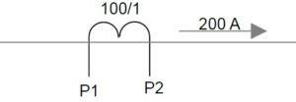

In the above figure, CT is defined by its terminal P1 & P2 and ratio 100/1. Primary circuit in which CT is connected is shown carrying a current of 200

A. The secondary current of CT will be 200 / 100 = 2 A.

Parameters of Current Transformer:

A current transformer is defined by its current Turn Ratio, Accuracy Class, [Accuracy Limit Factor](https://electricalbaba.com/accuracy-limit-factor-current-transformer/) and [Instrument Safety Factor (ISF)](https://etrical.blogspot.com/2017/12/instrument-safety-factor.html) etc. Accuracy class is determined by phase angle error and ratio error. In this post we will be discussing the basics. Before going into further discussion, it is better to understand some of the basic but important parameters. Ther are as follows:

* Turn Ratio is defined as the ratio of number of secondary winding turns to number of primary winding turns. It is often denoted by n and given as

n = Number of secondary winding turns / Number of primary winding

turns

* Transformation Ratio is defined as the ratio of primary winding current to secondary winding current. It is denoted by R and given as

R = primary winding current / Secondary winding current

You might think that n & R should be equal. Yes, correct but this is the ideal case but there is nothing ideal. There are always some losses associated in a CT and hence Turn Ratio and Transformation Ratio are not equal.This gave rise to ratio error. We will discuss it latter in this post.

* [Burden](https://etrical.blogspot.com/2016/06/burden-in-potential-transformer.html) is defined as the volt ampere (VA) of connected load across the terminals for secondary winding of CT.

Equivalent Circuit of Current Transformer:

The equivalent circuit and phasor diagram of current transformer is shown in figure below.

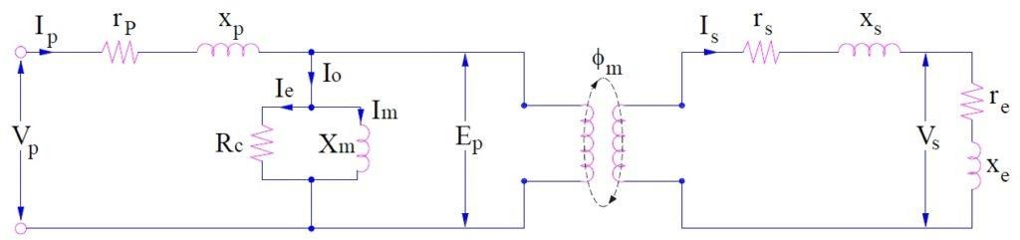

Where

n = turn ratio

rs = resistance of secondary winding xs = reactance of secondary winding

re = resistance of burden connected to secondary xe = reactance if burden connected to secondary Ep = Induced emf in CT primary

Es = Induced voltage in CT secondary Np = CT primary winding turns

Ns = CT secondary winding turns

Ip = CT primary winding current

Is = CT secondary winding current Ø = Flux in CT core

ɵ = Phase angle of CT

I0 = Excitation current of CT

Im = Magnetizing current of CT

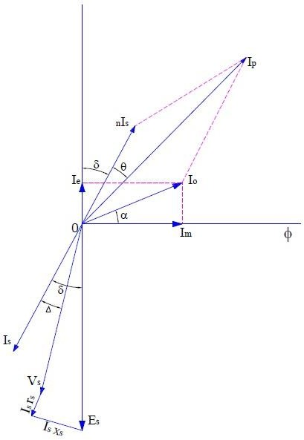Phasor Diagram of Current Transformer:

Carefully observe that the equivalent circuit and phasor diagram are same as that of power transformer. The phasor diagram is drawn assuming that connected burden is of lagging power factor. As CT is connected in series with the primary circuit whose current is to be measured, this means that primary current Ip of CT is not dependent on secondary burden rather it is determined by the primary circuit current.

1. Explain the operating principle of current transformer with a neat diagram. Mention the various causes of error and state the methods of reducing the errors.

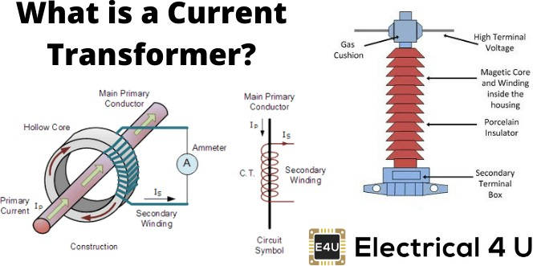

Definition of Instrument Transformer

[Instrument transformers](https://www.electrical4u.com/instrument-transformers/) means current transformer and [voltage transformer](https://www.electrical4u.com/voltage-transformer-or-potential-transformer-theory/) are used in [electrical power](https://www.electrical4u.com/electric-power-single-and-three-phase/) system for stepping down currents and voltages of the system for metering and protection purpose. Actually [relays](https://www.electrical4u.com/types-of-electrical-protection-relays-or-protective-relays/) and meters used for protection and metering, are not designed for high currents and voltages.

High currents or voltages of [electrical power system](https://www.electrical4u.com/electric-power-single-and-three-phase/) can not be directly fed to relays and meters. Current transformer steps down rated system [current](https://www.electrical4u.com/electric-current-and-theory-of-electricity/) to 1 Amp or 5 Amp similarly [voltage transformer steps down system](https://www.electrical4u.com/step-down-transformers/) voltages

to 110 V. The relays and meters are generally designed for 1 Amp, 5 Amp and 110 V.

So core of protection current transformer is so designed that it would not be saturated for long range of currents. If saturation of the core comes at lower level of primary current the proper reflection of primary current will not come to secondary, hence relays connected to the secondary may not function properly and protection system losses its reliability.

Suppose, you have one current transformer with current ratio 400/1 A and its protection core is situated at 500 A. If the primary current of the current transformer becomes 1000 A the secondary current will still be 1.25 A as because the secondary current will not increase after 1.25 A because of saturation. If actuating current of the [relay](https://www.electrical4u.com/types-of-electrical-protection-relays-or-protective-relays/) connected the secondary circuit of the CT is 1.5 A, it will not be operated at all even fault level of the power circuit is 1000 A.

The degree of accuracy of a protection current transformer may not be as fine as metering current transformer but it is also expressed by current transformer accuracy class or simply current transformer class or CT class as in the case of metering current [transformer](https://www.electrical4u.com/what-is-transformer-definition-working-principle-of-transformer/) but in little bit different manner.

1. Describe Compton’s dc potentiometer DC Crompton's Potentiometer :

DC Crompton's potentiometer is the laboratory-type potentiometer that is used to measure unknown emf effectively with a great degree of precision.

DC Crompton's potentiometer works on the principle of a slide wire potentiometer. In other words, the DC Crompton potentiometer is a modified version of a slide-wire potentiometer. It basically consists of a small slide wire which is circular in shape and a dial switch with calibrated resistors, as shown in the figure below.

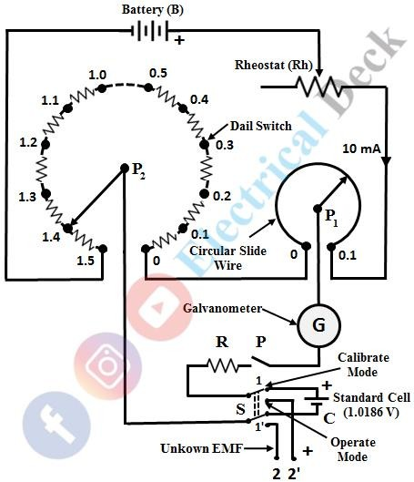

In the figure shown, B = Battery

Rh = Rheostat

G = Galvanometer

R = Protective resistance which is of order of 10 KΩ S = Double throw switch

C = Standard cell

In DC Crompton's potentiometer, the dial switch is divided into fifteen steps with each step having a resistance of 10Ω. Hence, the total resistance of dial switch is equal to 150Ω (15 X 10 = 150). The slide wire is in the form of a circular wire and has a resistance of 10Ω, with a single turn. A double- throw switch is provided for standardization and for measuring the unknown emf, one after the other.

A protective resistance is connected in series with the galvanometer in order to protect the galvanometer and is shorted when the galvanometer reaches the balanced condition. As the working current provided by the battery is 10 mA, the voltage drop across each step is 0.1 V and hence it has a total range of 1.5 V (1.5 x 10 = 15 V). If circular slide wire has 200 divisions, then each division in slide wire has a resolution of 0.0005 V (0.1/200 = 0.0005). Hence, it is possible to measure the readings up to 0.0001 V with great precision and accuracy by taking readings up to 1/5th division in the scale.

First, the potentiometer is to be standardized to the standard cell voltage (1.0186 V) by keeping the dial switch at 1.0 V and slide wire at 0.0186. After making these adjustments, switch S is operated in calibrate mode and key k is closed and the rheostat is adjusted in such a way that, the galvanometer shows null deflection. With this, the potentiometer is standardized to the voltage of standard cell which is connected between the terminals 1 and 1'.

Now, the switch is thrown into the operating mode for measuring the unknown emf connected between terminals 2 and 2'. The value of unknown emf can be measured directly from the dial switch and circular slide wire, after balancing the galvanometer to show null deflection. In this way, an unknown emf can be measured with great precision using DC Crompton's potentiometer.

1. List the applications of megger

* Used for the insulation of windings.
* Used to test electronic devices.
* Used to measure the resistance of insulators.

46.. Name the bridge used for measuring very low resistance.

Kelvin's Double Bridge Method: Kelvin's Double Bridge Method is a modification of the Wheatstone bridge method. Accurate measurement of very low resistance is possible with Kelvin's Double Bridge Method.

47. What is the working principle of megger?

Megger works on the principle of electromagnetic attraction. When a primary coil that is carrying current is placed under the vicinity of a magnetic field it experiences a force. This kind of force generates a torque that is made to deflect the pointer of the device which gives some reading.

48.. Classify the resistances according to the values

For the purposes of measurements, the resistances are classified into three major groups based on their numerical range of values as under: • Low resistance (0 to 1 ohm) • Medium resistance (1 to 100 kilo-ohm) and • High resistance (>100 kilo-ohm) Accordingly, the resistances can be measured by various ways, depending …

1. What are the methods of measurements of low resistance?

The different methods used for the measurement of Low resistance are as follows: Kelvin's Double bridge method. Potentiometer method. Ducter ohmmeter.

1. What is ground fault?

An electrical system can experience a number of different types of faults— defined as any abnormal flow of electricity. A ground fault is a type of fault in which the unintentional pathway of the straying electrical current flows directly to the earth (to the ground). Here, too, the circuit is "short," in that it has bypassed the circuit wiring, so a ground fault can technically be defined as one type of short circuit. And, as with any short circuit, the immediate impact is a sudden reduction in resistance that causes current to flow in an unimpeded fashion. Like other types of short circuits, a ground fault causes the circuit breaker to trip due to the uncontrolled flow.

But for an electrician, a ground fault is generally defined as the situation when a hot wire makes contact with either the grounding wire or a grounded portion of the system, such as a metal electrical box. Electricians, therefore, think of a ground fault as being different than a short circuit, although an electrical engineer would see it somewhat differently.

The main danger of ground faults comes in the likelihood of shock if a person happens to be in contact with the path of least resistance to the

ground. This is why the danger of shock is much more pronounced in situations where a person is standing on the ground or in a damp location.1

Protection against ground faults is offered by circuit breakers that trip if the flow of electricity suddenly increases, and by a system of grounding wires in the circuits that provide a direct pathway back to ground should current stray outside its established circuit wiring. There are also ground-fault circuit interrupter outlets that can be used in situations where ground faults are particularly likely, such as in outdoor locations, near plumbing fixtures, and in below-grade locations.

1. State two applications of vibration galvanometer.

A vibration galvanometer is a type of [mirror galvanometer](https://en.wikipedia.org/wiki/Mirror_galvanometer), usually with a coil suspended in the gap of a magnet or with a permanent magnet suspended in the field of an [electromagnet](https://en.wikipedia.org/wiki/Electromagnet). The natural [oscillation](https://en.wikipedia.org/wiki/Oscillation_frequency) [frequency](https://en.wikipedia.org/wiki/Oscillation_frequency) of the moving parts is carefully tuned to a specific [frequency](https://en.wikipedia.org/wiki/Frequency); commonly 50 or 60 Hz. Higher frequencies up to 1 kHz are possible. Since the frequency depends on the mass of the moving elements, high frequency vibration galvanometers are very small with light coils and mirrors. The tuning of the vibration galvanometer is done by adjusting the tension of the suspension spring.

The vibration galvanometer is used for detecting alternating currents in the frequency of its natural resonance. Most common application is as a null indicating instrument in AC [bridge circuits](https://en.wikipedia.org/wiki/Bridge_circuit) and current comparators.

The sharp [resonance](https://en.wikipedia.org/wiki/Resonance) of the vibration galvanometer makes it very sensitive to changes in the measured current frequency and it can be used as an accurate tuning device.

1. What are the limitations of Maxwell’s bridge? The disadvantages of a Maxwell Bridge are:
   * The variable standard capacitor is very expensive.
   * The bridge is limited to measurement of low quality coils (1 < Q < 10) and it is also unsuitable for low value of Q (i.e. Q < 1) from this we conclude that a Maxwell bridge is used suitable only for medium Q coils